# Archer Complaints Tracking

Governing bodies such as the Office of the Superintendent of Financial Institutions (OSFI) in Canada and the Office of the Comptroller of the Currency (OCC) in the U.S. require organizations to implement and adhere to policies and procedures in regard to how complaints, internal and external to the organization, are managed. Complaints should be managed in an orderly fashion and timely manner.  Complaints that are not dealt with can pose a risk to the organization in many aspects. One aspect is mandated by the governing bodies to adhere to their guidelines. The other aspect is reputation risks for the organization. The governing bodies require organizations to report information regarding the complaints, how they are handled, and how long it takes to handle them. Therefore, customers need a way to track the complaints and report information to the regulators.

On this page

* Release notes
  + Release 6.11
    - New and changed features
* Overview of Archer complaints tracking
  + Key features and benefits
  + Prerequisites (ODA and system requirements)
  + Compatible use cases and Applications
    - Related Applications
* Archer Complaints Tracking components
  + Architecture diagram
  + Swim Lane diagram
  + Applications
  + Personas and Access Roles
  + Permissions chart
* Installing Archer complaints tracking
  + Installation overview
    - Task 1: Prepare for the installation
    - Task 2: Install the package
    - Task 3: Set up data feeds
    - Task 4: Test the installation
  + Installing the package
    - Task 1: Back up your database
    - Task 2: Import the package
    - Task 3: Map objects in the package
    - Task 4: Install the package
    - Task 5: Review the package installation log
* Configuring the Archer complaints tracking
  + Update complaint reviewer dashboard
    - Task 1: Create my assigned remediation plans featured metric report
    - Task 2: Create my assigned exception requests featured metric report
    - Task 3: Update the complaint reviewer dashboard
  + (Optional) Register complaints from speak up
    - Task 1: Create report A2A register complaints
    - Task 2: Import the A2A register complaints data feed
* (Optional) Configure Archer Engage for new complaint submission
* Upgrading Archer complaints tracking
* Using Archer complaints tracking
  + Task 1: Document complaint
  + Task 2: Assign complaint owner
  + Task 3: Investigate, resolve and submit for review
  + Task 4: Resubmit complaint
  + Task 5: Review complaint
  + Task 6: Resubmit for review
  + Task 7: Close the complaint
  + Task 8: Provide customer satisfaction
  + Task 9: Regulatory communication
* Certification environment

## Release notes

### Release 6.11

November 2022 Update: Added product identifier (E4BU) for the Engage Custom Object.

#### New and changed features

| Component | Description |
| --- | --- |
| Dashboards | 1. Updated Complaint Submitter Dashboard to Landing page iview. 2. Updated Complaint Owner and Complaint Review dashboards to utilize latest reporting features and reduce clutter |
| Application | 1. New fields for Archer Engage portal integration 2. Provided custom object for publishing complaint register template to Archer Engage portal. 3. Few field and layout changes were made. |

## Overview of Archer complaints tracking

### Key features and benefits

The Archer Complaints Tracking offering enables organizations to:

* Document complaints internal and external to the organization
* Conduct an investigation to determine impacts to the organization
* Document findings and determine a course of action for resolution
* Monitor and report complaint resolution and satisfaction for regulatory requirements

Benefits include:

* Consistent and repeatable process for tracking and managing complaints
* Minimize customer and employee dissatisfaction in regard to handling complaints
* Compliance with corporate obligations and regulatory requirements around complaint management policy and procedures

### Prerequisites (ODA and system requirements)

| Components | Prerequisites |
| --- | --- |
| Archer Solution Area(s) | Archer Regulatory & Corporate Compliance Management |
| Archer Use Case(s) | Archer Issues Management |
| Archer Applications | Requirements for the installation and operation of Archer Complaints Tracking includes the following use cases:   * Findings– (Archer Issues Management) * Exception Requests– (Archer Issues Management) * Remediation Plans– (Archer Issues Management) * Business Unit–(Archer Issues Management, Archer Business Impact Analysis, Archer Third Party Catalog, Archer IT Asset Catalog, Archer Business Asset Catalog, Archer Key Indicator Management) |
| Uses Custom Application | Yes |
| Requires On-Demand License | Yes. One (1) On-Demand Licenses are required. |
| Archer Requirements | Archer 6.11 and later |
| Partner/Vendor Requirements | Valid License is required |
| Operating System | Windows Server 2019/2022 |
| Database Server | Microsoft SQL Server 2017/2019 (64-bit) |
| Web Server | Microsoft IIS 10 |

### Compatible use cases and Applications

#### Related Applications

| Application | Use Case | Primary Purpose(s) of the Relationship |
| --- | --- | --- |
| Speak Up | Archer Speak Up App-pack | * To submit complaints anonymously and track them. |
| Third Party Profile | Archer Third Party Catalog | * To associate and track complaints against third party and their profile. |
| Products and Services | Archer Third Party Risk Management, Archer Business Asset Catalog, Archer Third Party Engagement, Archer Bottom-Up Risk Assessment | * To associate and track complaints against a product. |
| Contacts | Archer Audit Engagements and Workpapers, Archer Incident Management, Archer Third Party Catalog, Archer IT Asset Catalog, Archer Data Governance, Archer Business Asset Catalog, Archer Loss Event Management, Archer Self-Assessment Management | * To associate and track complaints against Employees. |
| Business Process | Archer Audit Engagements & Workpapers; Archer Bottom-Up Risk Assessment; Archer Business Asset Catalog; Archer Business Impact Analysis; Archer Data Governance; Archer IT Controls Assurance; Archer Third Party Engagement; Archer Top-Down Assessment | * To relate processes affected by the complaints. |
| Control Procedures | Archer Controls Assurance Program Management; Archer Data Governance; Archer Financial Controls Monitoring; Archer IT Controls Assurance; Archer IT Risk Management; Archer Information Security Management System; Archer PCI Management; Archer Top-Down Assessment | * To relate failed controls to the complaints. |
| Policies | Archer Policy Program Management | * To relate violated policies to the complaints. |
| Control Standards | Archer Policy Program Management | * To relate failed control standards to the complaints. |
| Risk Register | Archer IT Risk Management; Archer Information Security Management System; Archer Risk Catalog; Archer Top-Down Assessment | * To identify, track and provide visibility for complaints that pose a risk to the organization. |
| Incidents | Archer Incident Management | * To relate and track incidents resulting from the complaints. |
| Security Incidents | Archer Cyber Incident and Breach Response | * To relate and track Cyber Incidents resulting from the complaints. |
| Ethics Violation | Archer Incident Management | * To relate and track violations in ethics resulting from the complaints. |
| Loss Events | Archer Loss Event Management | * To relate and track Loss Events resulting from the complaint. |
| Regulatory Communication | Archer Privacy Program Management | * To track Regulatory Communications made regarding complaints. |

## Archer Complaints Tracking components

### Architecture diagram

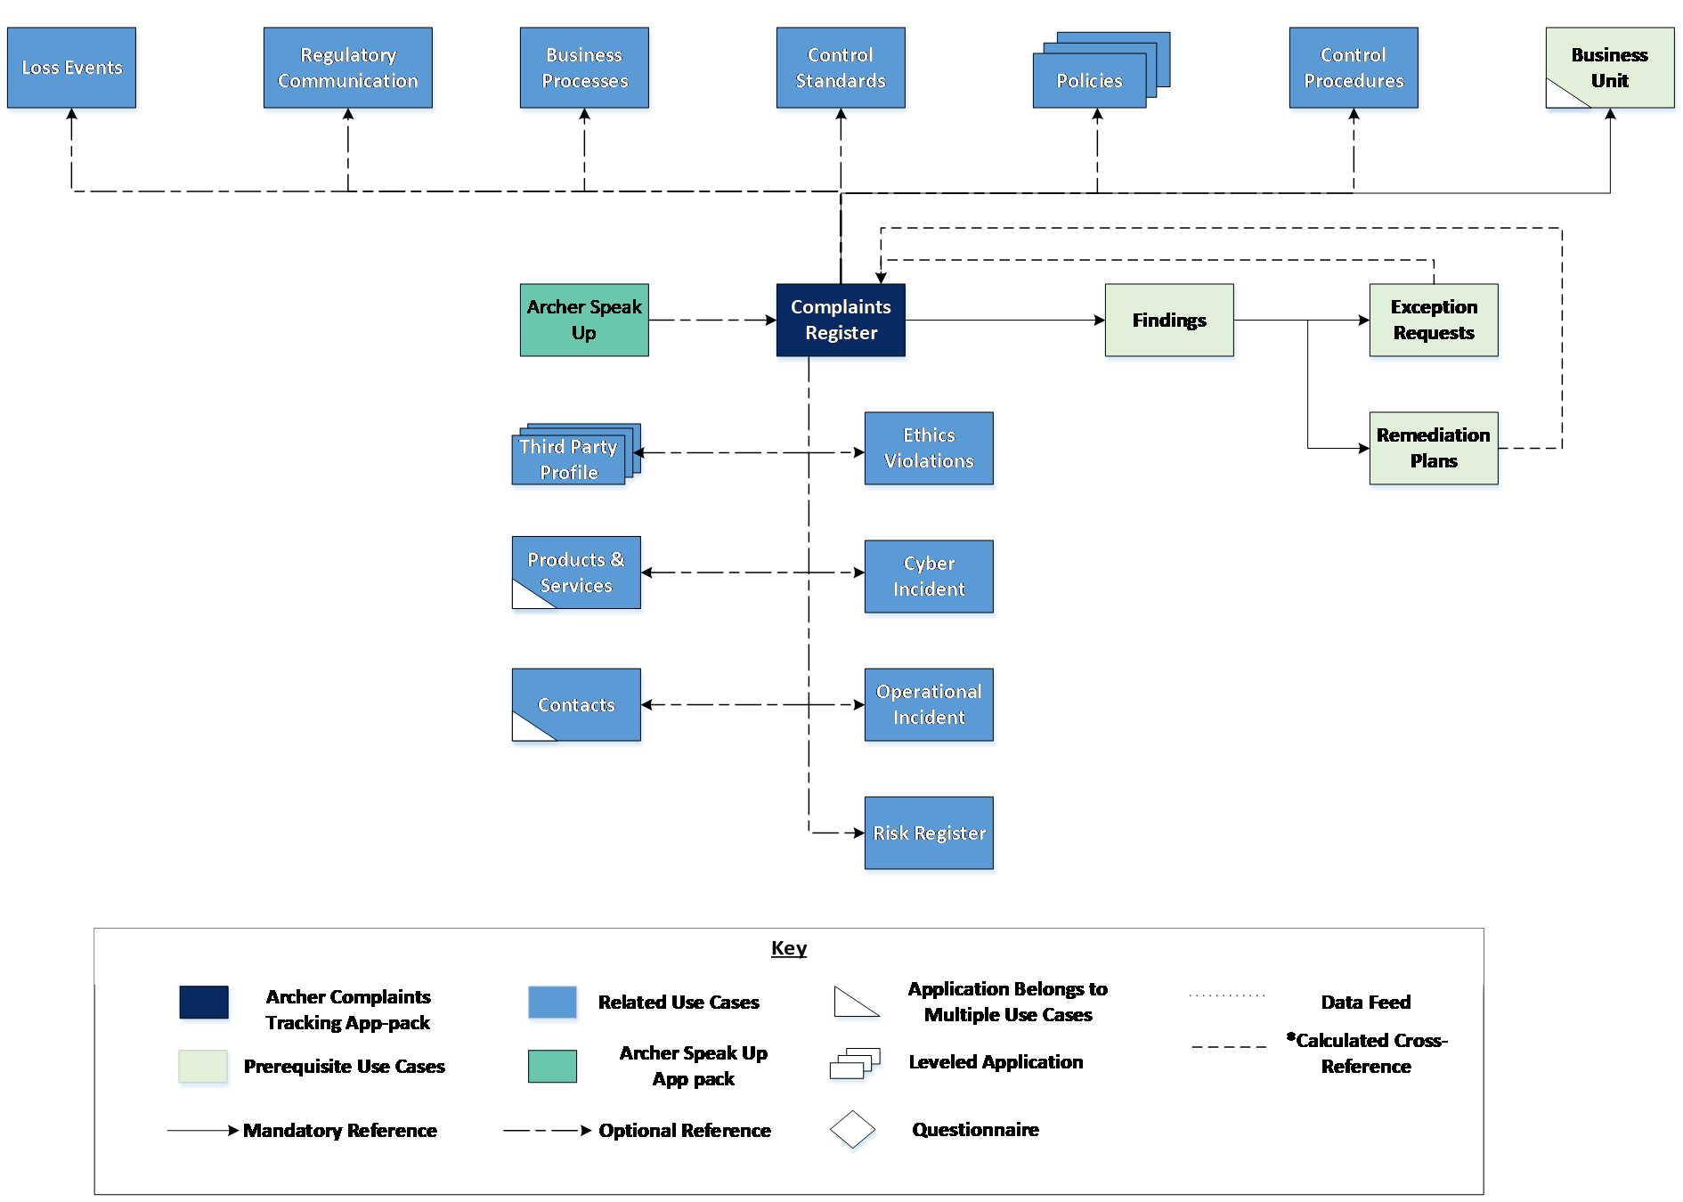

### Swim Lane diagram

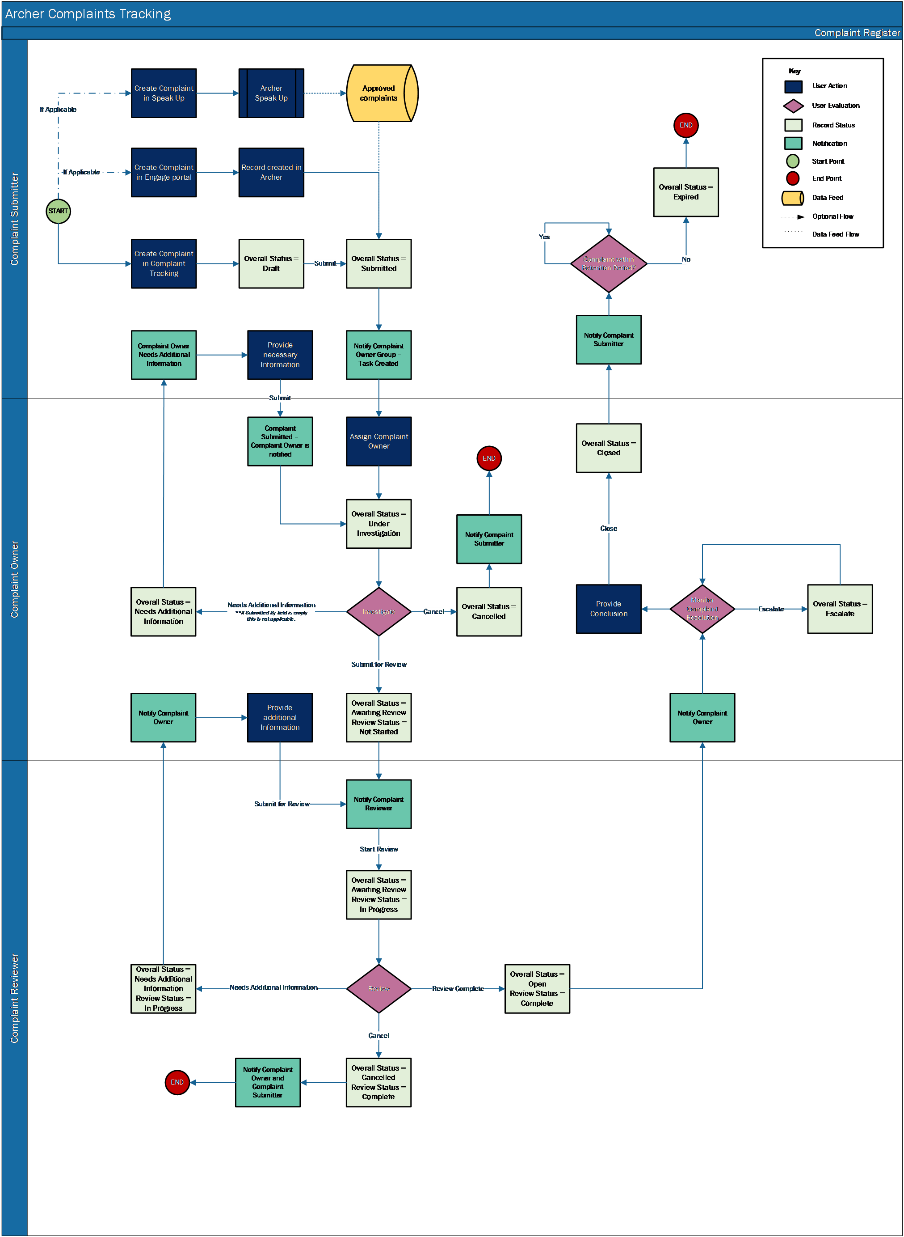

### Applications

| Application | Description |
| --- | --- |
| Complaints Register | The Complaints Register application documents all the information regarding complaints reported for further investigation. It captures the results from the investigation, the remediation plans or exception requests and supporting information. |

### Personas and Access Roles

The following table describes the functions that make up the application’s organization roles. Depending on the organization of your company, these functions and responsibilities may vary.

| Function | Description |
| --- | --- |
| Complaint Submitter | The Complaint Submitter is responsible for submitting complaints.  The complaint can be submitted on behalf of someone else or does not necessarily pertain to the submitter.  This person can be anyone internal or external to the organization. |
| Complaint Owner | The Complaint Owner is responsible for reviewing the complaints, determining a resolution and addressing the issue. This person is typically someone in the Compliance Management or Ethics Management department. |
| Complaint Reviewer | The Complaint Reviewer is responsible for overseeing the complaints management process and reporting complaints for regulatory compliance.  They review and approve complaints to ensure they are within compliance. This person is typically a manager in the Compliance Management or Ethics Management department. |

### Permissions chart

| Applications | Complaints Tracking: Complaint Submitter | Complaints Tracking: Complaint Owner | Complaints Tracking: Complaint Reviewer |
| --- | --- | --- | --- |
| Complaints Register | CRU | CRU | CRU |
| Findings | CRU | CRU | CRU |
| Remediation Plans | CRU | CRU | CRU |
| Exception Requests | CRU | CRU | CRU |
| Business Unit | R | R | R |
| Third Party Profile | R | R | R |
| Contacts | R | R | R |
| Products and Services | R | R | R |
| Control Standards |  | R | R |
| Control Procedures |  | R | R |
| Policies |  | R | R |
| Business Processes |  | R | R |
| Regulatory Communication |  | R | CRU |
| Loss Events |  | R | R |
| Risk Register |  | R | R |
| Incidents |  | R | R |
| Security Incidents |  | R | R |
| Ethics Violations |  | R | R |

C = Create, R = Read, U = Update, D = Delete

Users should at least have read access at record level for the applications related to Complaints Register to view the related records.

## Installing Archer complaints tracking

### Installation overview

Complete the following tasks to install the offering.

#### Task 1: Prepare for the installation

1. Ensure that your Archer system meets the following requirements:
   * Archer Platform version 6.11 or later.
2. Obtain the Data Dictionary for the ODA by contacting your Archer Account Representative. The Data Dictionary contains the configuration information for the use case.
3. Read and understand the "Packaging Data" section of Archer Help.

#### Task 2: Install the package

Installing a package requires that you import the package file, map the objects in the package to objects in the target instance, and then install the package. See Installing the Application Package for complete information.

#### Task 3: Set up data feeds

You must import and schedule each use case data feed that you want to use. See Setting Up Data Feeds for complete information.

#### Task 4: Test the installation

Test the application according to your company standards and procedures, to ensure that the use case works with your existing processes.

### Installing the package

#### Task 1: Back up your database

There is no Undo function for a package installation. Packaging is a powerful feature that can make significant changes to an instance. Archer strongly recommends backing up the instance data base before installing a package. This process enables a full restoration if necessary.

An alternate method for undoing a package installation is to create a package of the affected objects in the target instance before installing the new package. This package provides a snapshot of the instance before the new package is installed, which can be used to help undo the changes made by the package installation. New objects created by the package installation must be manually deleted.

#### Task 2: Import the package

1. Go to the Install Packages page.
   1. From the menu bar, click Admin menu.
   2. Under Application Builder, click Install Packages.
2. In the Available Packages section, click Import.
3. Click Add New, then locate and select the package file that you want to import.
4. Click OK.

The package file is displayed in the Available Packages section and is ready for installation.

#### Task 3: Map objects in the package

**Important:** This step is required only if you are upgrading to a later version of [ODA name].

1. In the Available Packages section, select the package you want to map.
2. In the Actions column, click  for that package.

The analyzer runs and examines the information in the package. The analyzer automatically matches the system IDs of the objects in the package with the objects in the target instances and identifies objects from the package that are successfully mapped to objects in the target instance, objects that are new or exist but are not mapped, and objects that do not exist (the object is in the target but not in the source).

**Note:** This process can take several minutes or more, especially if the package is large, and may time out after 60 minutes. This time-out setting temporarily overrides any IIS time-out settings set to less than 60 minutes.

When the analyzer is complete, the Advanced Package Mapping page lists the objects in the package file and corresponding objects in the target instance. The objects are divided into tabs, depending on whether they are found within Applications, Solutions, Access Roles, Groups, Sub- forms, or Questionnaires.

1. On each tab of the Advanced Mapping Page, review the icons that are displayed next to each object name to determine which objects require you to map them manually.

| Icon | Name | Description |
| --- | --- | --- |
| Awaiting mapping review | Awaiting Mapping Review | Indicates that the system could not automatically match the object or children of the object to a corresponding object in the target instance.  Objects marked with this symbol must be mapped manually through the mapping process.  **Important:** New objects should not be mapped. This icon should remain visible. The mapping process can proceed without mapping all the objects.  **Note:** You can execute the mapping process without mapping all the objects. The Awaiting mapping review icon is for informational purposes only. |
| Checkmark | Mapping  Completed | Indicates that the object and all child objects are mapped to an object in the target instance. Nothing more needs to be done with these objects in Advanced Package Mapping. |
| Missing objects | Do Not  Map | Indicates that the object does not exist in the target instance or the object was not mapped through the Do Not Map option. These objects will not be mapped through Advanced Package Mapping, and must be remedied manually. |
|  | Undo | Indicates that a mapped object can be unmapped. This icon is displayed in the Actions column of a mapped object or object flagged as Do Not Map. |

1. For each object that requires remediation, do one of the following:
   * To map each item individually, on the Target column, select the object in the target instance to which you want to map the source object. If an object is new or if you do not want to map an object, select Do Not Map from the drop-down list.
   * **Important:** Ensure that you map all objects to their lowest level. When objects have child or related objects, a drill-down link is provided on the parent object. Child objects must be mapped before parent objects are mapped. Fo rmore details ,see "Mapping Parent/Child Objects" in Archer Help.
   * To automatically map all objects in a tab that have different system IDs but the same object name as an object in the target instance, do the following:
2. In the toolbar, click Auto Map.
3. Select an option for mapping objects by name.

| Option | Description |
| --- | --- |
| Ignore case | Select this option to match objects with similar names regardless of the case of the characters in the object names. |
| Ignore spaces | Select this option to match objects with similar names regardless of whether spaces exist in the object names. |

1. Click OK.

* The Confirmation dialog box opens with the total number of mappings performed. These mappings have not been committed to the data base yet and can be modified in the Advanced Package Mapping page.

1. Click OK.

* To set all objects in the tab to Do Not Map, in the toolbar, click Do Not Map.

**Note:** To undo the mapping settings for any individual object, click  in the Actions column.

When all objects are mapped, the Checkmark icon is displayed in the tab title. The Missing objects icon is displayed next to the object to indicate that the object will not be mapped.

1. Verify that all other objects are mapped correctly.
2. (Optional) To save your mapping settings so that you can resume working later, see "Exporting and Importing Mapping Settings" in Archer Help.
3. Once you have reviewed and mapped all objects, click .
4. Select I understand the implications of performing this operation and click OK.

The Advanced Package Mapping process updates the system IDs of the objects in the target instance as defined on the Advanced Package Mapping page. When the mapping is complete, the Import and Install Packages page is displayed.

**Important:** Advanced Package Mapping modifies the system IDs in the target instance. Any Data Feeds and Web Service APIs that use these objects will need to be updated with the new system IDs.

#### Task 4: Install the package

All objects from the source instance are installed in the target instance unless the object can not be found or is flagged to not be installed in the target instance. A list of conditions that may cause objects not to be installed is provided in the Log Messages section. A log entry is displayed in the Package Installation Log section.

1. Go to the Install Packages page.
   1. From the menu bar, click Admin menu.
   2. Under Application Builder, click Install Packages.
2. In the Available Packages section, locate the package file that you want to install, and click Install.
3. In the Configuration section, select the components of the package that you want to install.
   * To select all components, select the top-level checkbox.
   * To install only specific global reports in an already installed application, select the check box associated with each report that you want to install.

**Note:** Items in the package that do not match an existing item in the target instance are selected by default.

1. In the Configuration section, under Install Method, select an option for each selected component. To use the same Install Method for all selected components, select a method from the top-level drop-down list.

**Note:** If you have any existing components that you do not want to modify, select Create New Only. You may have to modify those components after installing the package to use the changes made by the package.

1. In the Configuration section, under Install Option, select an option for each selected component. To use the same Install Option for all selected components, select an option from the top-level drop-down list.

**Note:** If you have any custom fields or formatting in a component that you do not want to lose, select Do not Override Layout. You may have to modify the layout after installing the package to use the changes made by the package.

1. To deactivate target fields and data-driven events that are not in the package, in the Post-Install Actions section, select the Deactivate target fields and data-driven events that are not in the package checkbox. To rename the deactivated target fields and data-driven events with a user-defined prefix, select the Apply a prefix to all deactivated objects check box, and enter a prefix. This can help you identify any fields or data-driven events that you may want to review for clean up post-install.
2. Click Install.
3. Click OK.

#### Task 5: Review the package installation log

1. Go to the Package Installation Log tab of the Install Packages page.
   1. From the menu bar, click Admin menu.
   2. Under Application Builder, click Install Packages.
   3. Click the Package Installation Log tab.
2. Click the package that you want to view.
3. In the Package Installation Log page, in the Object Details section, click View All Warnings.
4. Manually activate Advanced Workflow by clicking Active button in Advanced Workflow tab in Archer Complaints Register application.

## Configuring the Archer complaints tracking

### Update complaint reviewer dashboard

#### Task 1: Create my assigned remediation plans featured metric report

1. Go to Remediation Plans Application Advanced Search:
   1. From the menu bar, click Issues Management.
   2. Under Solutions, click Issues Management.
   3. Under Applications, click Remediation Plans.
   4. In the Remediation Plans default results page, click Modify.
2. Select Statistics Mode check box in Fields to display section.
3. Select Count of Name in Fields in Display.
4. In Filters add the following:
   1. Fields to Evaluate:
      1. Remediation Plan Manager Contain Current User
      2. Remediation Plan Owner Contain Current User
      3. Status Does Not Contain Closed
      4. Complaints Register (Remediation Plans) Does Not Contain No Selection
   2. Advanced Operator Logic: (1 OR 2) AND 3 AND 4
   * 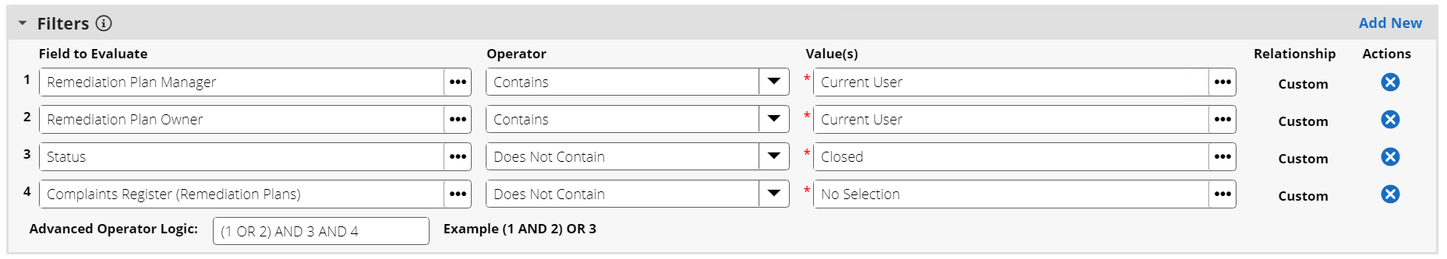
5. Click on Search button.
6. Select “Chart Only” and “Featured Metric” in the Chart tool bar in the search results page.
7. Click on Save.
8. Provide Report Name as “My Assigned Remediation Plans”.
9. In Report Type section select “Global Report”.
10. Click on Save.

#### Task 2: Create my assigned exception requests featured metric report

1. Go to Exception Requests Application Advanced Search:
   1. From the menu bar, click Issues Management.
   2. Under Solutions, click Issues Management.
   3. Under Applications, click Exception Requests.
   4. In the Exception Requests default results page, click Modify.
2. Select Statistics Mode check box in Fields to display section.
3. Select Count of Exception Description in Fields in Display.
4. In Filters add the following:
   1. Fields to Evaluate:
      1. Submitter Contains Current User
      2. Management Reviewer Contains Current User
      3. Reviewer Contains Current User
      4. Complaints Register (Exception Requests) Does Not Contain No Selection
   2. Advanced Operator Logic: (1 OR 2 OR 3) AND 4
   * 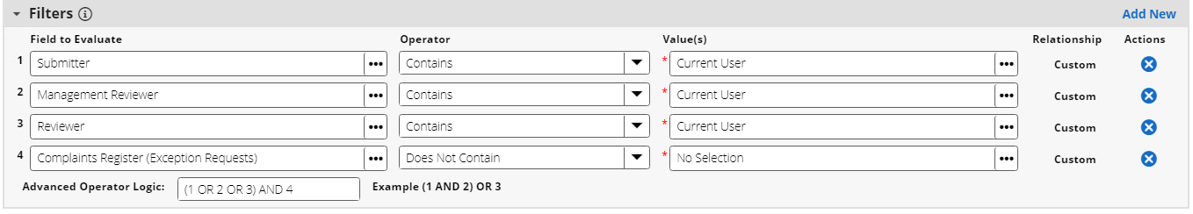
5. Click on Search button.
6. Select “Chart Only” and “Featured Metric” in the Chart tool bar in the search results page.
7. Click on Save.
8. Provide Report Name as “My Assigned Exception Requests”.
9. In Report Type section select “Global Report”.
10. Click on Save.

#### Task 3: Update the complaint reviewer dashboard

1. Go to Global iViews:
   1. From the menu bar, click Administration.
   2. Under Workspaces and Dashboards, select Global iViews.
2. Open iView “My Assigned Remediation Plans”.
3. Select report “My Assigned Remediation Plans”, created in Task 1, in the iView.
4. Click on Save.
5. Go back to the Global iViews listing page
6. Open iView “My Assigned Exception Requests”.
7. Select report “My Assigned Exception Requests”, created in Task 2, in the iView.
8. Click on Save.

* **Note:** Go to Complaint Reviewer dashboard and verify if My Assigned Remediation Plans and My Assigned Exception Requests iViews are visible. If it is not visible perform the below steps.

1. Go to Complaint Reviewer Dashboard:
   1. From the menu bar, click Complaint Tracking.
   2. Under Dashboards, select Complaint Reviewer.
2. Click on the Dashboard options Ellipses and click on Add iView content.
3. Select the radio button “Select from Global iView Library”.
4. Select iViews “My Assigned Remediation Plans”, “My Assigned Exception Requests” and click OK.
5. Place the iViews to the top right column.
6. Click on Save to save the dashboard changes.

### (Optional) Register complaints from speak up

Please find the steps below to create approved complaints records in Complaint Register application.

Archer Speak Up App-pack allows users to submit ideas, report issues and file complaints in a single repository. For detailed information on installation and usage of the app-pack please check Archer Speak Up documentation in [Archer Community](https://www.archerirm.community/t5/exchange-overviews/archer-speak-up-app-pack/ta-p/564075)

**Note:** The data feed described in this guide is being provided as a reference implementation for evaluation and testing purposes.  It may or may not meet the needs and use cases for your organization.  If additional customizations or enhancements are needed, it is recommended that customers contact Archer Help for assistance.

#### Task 1: Create report A2A register complaints

This report displays all approved anonymous speak up requests.

1. Log in to your instance.
2. Go to the Archer Speak Up Reports Page
   1. From the menu bar, click dropdown beside Archer Speak Up.
   2. Under Solutions, click Archer Speak Up.
   3. Under Applications, click  beside Speak Up.
3. Click New to create a new report.
4. In Fields to display add the following fields from Speak Up in the Available window to the Selected window:
   * Request ID
   * Title
   * Description
   * Date of Occurrence
   * Submit Date
   * Submitted By
   * Anonymous Submission
   * Complaint Against
   * Business Unit
5. In Filters section select following fields. The default filters mentioned above will add all approved/completed complaints. Modify the filters as per your requirement:

| Field to Evaluate | Operator | Value(s) | Relationships |
| --- | --- | --- | --- |
| Request Type | Contains | Complaint | AND |
| Overall Status | Contains | Approved  Completed | AND |
| Complaints Register (Speak Up) | Contains | No Selection |  |

1. Click Search.
2. Click Save.
3. In the Report Information section, in the Name field, enter A2A Register Complaints.
4. In the Report Type section, in the Permissions field, select Global Report.
5. Click Save.
6. From the search results page, in the Save drop-down menu, click Save Report Changes.
7. In the Report Information section, copy the numeric value from the ID field and save it for use when importing the A2A Register Complaints data feed.

**Note:** Do not include the braces {} in the copied text. This numeric ID is used in the Report field in the A2A Register Complaints data feed. See step 9b of Task 2: Import the A2A Register Complaints Data Feed.

#### Task 2: Import the A2A register complaints data feed

This is a data feed to create complaints in complaint register.

1. Log in to your instance.
2. Go to the Manage Data Feeds page:
   1. From the menu bar, click Admin menu.
   2. Under Integration, click Data Feeds.
3. In the Manage Data Feeds section, click Import.
4. Locate and select the A2A Register Complaints.dfx5 data feed file.
5. Verify settings in the General tab.
   1. In the General Information section, set the Status field to Active.
   2. In the Feed Information section, confirm that the Target field is set to Complaints Register.
6. Click the Transport tab.
7. In the Transport section, confirm that the Transport Method field is set to Archer Web Services Transporter.
8. In the Security section, in the URL field, insert the URL to your instance.
9. In the Transport Configuration section, do the following:
   1. In the Search Type field, confirm that Report ID selected.
   2. In the Report field, insert the report ID that you obtained in step 10 of Task 1: Create Report A2A Register Complaints.
   3. In the User Name field, enter a user name of a user who has read access to speak up records.
   4. In the Instance field, enter the name of your instance.
   5. In the Password field, enter the password of the username you provided in the User Name field.
10. If you are an Archer SaaS/Hosted customer, in the Proxy section, set the Proxy Options field to Use System Proxy.
11. Click Save.
12. Verify the Data Map tab.
13. In Run Configuration Tab, schedule the data feed run time.
14. Click Run Now to run the data feed and test.

## (Optional) Configure Archer Engage for new complaint submission

Customers with Archer Engage enabled in their organization can configure Archer Complaints Tracking to allow new complaint submission through Archer Engage portal. Archer Engage should be of version 2.0.0 or above.

To know about Archer Engage visit [Archer Community](https://www.archerirm.community/t5/product-advisories/archer-announces-availability-of-archer-engage-release-v3-0-0/ta-p/685698).

Perform the following changes to configure and publish the complaint template and generate the link for new complaint creation in Engage. This is a one-time action required to publish the link for new complaint in Engage. These set of actions need to be performed by your Archer Administrator.

1. Open Complaint Register application.
   1. From the menu bar, click Admin menu.
   2. Under Application Builder, click Applications.
   3. Under Applications, click Complaints Register.
2. Edit Custom Object Publish Complaint Template
   1. In 000 Default Layout’s Designer Tab under Layout Objects “Publish Complaint Template” custom object can be found.
   2. Click on custom object to Edit.
3. Update 007 Engage Create New Layout: Under Layouts select 007 Engage Create New Layout and update the layout with fields which you want to publish to the Engage. For supported field types, refer to Archer Engage documentation in [Archer Help](https://help.archerirm.cloud/engage/Content/Engage/configuring.htm).
4. In the custom code update the following:
   1. Layout Id: Layout Id for “007 Engage Create New Layout” in the Application. If you wish to publish a different layout, use that layout id. Layout id can be found in the Layout Properties in the Designer tab. Example: 568
   2. User Id: The numeric Id of the user (from the to receive the email containing the New Record creation URL. To identify the user Id go to Access Control > Users. Hover the mouse on the username. A numeric number would be displayed in the left corner of the page. Example: 210
   3. EmailAccessConfig: Restrict the email domains which can receive the published link.
      1. Domains - Use to specify domains for access control. Provide your organization’s domain name. Example: archerirm.com
      2. AccessConfig - Use one of the following options to control access:
         1. Allow - Restricts record creation to the email domains listed in Domains. You must have at least 1 email listed in Domains.
         2. Deny - Denies record creation to those email domains listed in Domains. You must have at least 1 email listed in Domains.
         3. None - No restrictions.
   4. publishNewRecordTemplateURL: Use the URL for your Archer Engage Agent deployment. Example: '/engage/api/template/Publish'
5. Save the Custom Object.
6. Steps to Publish the link:
   1. Place the custom object on the default layout and save it.
      1. Place the custom object in an existing section if you wish to move it off-layout once the link is published.
      * OR
      1. Place the custom object in a new section. Create a DDE to hide it from all users except for administrators.
   2. Create a new complaint record:
      1. From the menu bar, click Complaints Tracking.
      2. Under Solutions, click Complaints Tracking.
      3. Under Applications, click Complaints Register.
      4. Click New Record.
   3. Click button “Publish Template”
   4. After publishing is complete the button message will change to “Publish Successful”. The email account of the user configured in the custom object will receive the link to create new complaint in Archer Engage portal.
   5. The custom object in application can be moved off-layout if required. If not, custom object should be hidden from all users and should be accessible to only administrators.
7. Update field logic for “Submitted Through Engage” field: This field is used to display the Engage Details section in complaint record in Archer. This is a new values list field with values Yes/No. This field is set to Yes default. This field is set to No via a data driven event if submitted manually. Current logic only assumes that data is only entered manually or through engage. If there are other external sources for the complaint (import/data feed input etc) update the logic as per your configuration.
8. The published link can now be shared to the users to create new complaint.

## Upgrading Archer complaints tracking

For the Complaints Tracking 6.11 release, the components have been updated to align with the 6.11 release changes. If you are upgrading from previous version to version 6.11 or later, be aware of the following changes.

**Note:**

* Upgrade customers are suggested to perform impact analysis due to the changes before performing the package installation.
* While installing the package please note that advanced workflow in your Complaints Register application would be replaced with the advanced workflow from the package.
* If Override Layout(s) was selected in package selector for the components during package installation, layouts would be overridden.
* Upon package installation, iViews will not be removed from dashboard and Report will not be removed from iViews. This is a manual task. iViews removed from the dashboard would be visible in the bottom of the dashboard. A manual cleanup is required.
* Perform a data import to update Submitted Through Engage field to No for the existing records.

The following table summarizes the changes made to Complaints Tracking app-pack in the 6.11 release. Please refer to data dictionary for the detailed list of the components.

| Complaints Register | Changes Made |
| --- | --- |
| New Fields | 1. Submitted Through Engage: Values list field with values Yes/No.  * **Note:** This field is set to Yes default. This field is set to No via a data driven event if submitted manually. Current logic only assumes that data is only entered manually or through engage. If there are other external sources for the complaint (import/data feed input etc.) update the logic as per your configuration.  1. Submitter Name: A text field to capture the submitter name in engage portal. 2. Submitter Email: A text field to capture the submitter email in engage portal if user wishes to receive further updates on the submitted complaint. |
| Updated Fields | 1. Complaint Description: Made the field required. 2. History Log: Reduced tracking to only 2 fields Complaint and Complaint Description.  * **Note:** Upon package install this will not be updated. Update manually if required  1. Submitter Notified Upon Complaint Owner Assignment: Updated calculation to consider the Engage submission. 2. Submitter Notified Upon Reviewer Assignment: Updated calculation to consider the Engage submission. |
| Layouts | 1. Default Layout:    1. Created New Complaint Details section and moved “Business Unit, Complaint Submitted Anonymously?, Complaint Origin, Complaint Target, Related Complaints, Related Speak-up Requests, Related Contacts, Related Third Party, Product and Service "fields from General Information Section.    2. Created new section Engage Details with fields Submitted through Engage, Submitter Name, Submitter Email.    3. Default Action: Removed Read-Only for "Complaint Submitted Anonymously?". Added Do Not Display for Engage Details section.    4. Added new Set  Values List Action “Submitted Through Engage” for Default Rule.    5. "Overall Status = Draft" Action: Hide new Complaint Details section and the Related Complaints section    6. Added new rule “Submitted Through Engage = Yes” and action “Display Engage Details Section” to display engage details section.    7. Updated Draft instructions 2. 001 Investigate and Resolve Layout:    1. Created New Complaint Details section and moved  "Business Unit, Complaint Submitted Anonymously?, Complaint Origin, Complaint Target, Related Complaints, Related Speak-up Requests, Related Contacts, Related Third Party, Product and Service "fields from General Information Section.    2. Created new section Engage Details with fields Submitted through Engage, Submitter Name, Submitter Email.    3. Default Action: Removed Read-Only for Business Unit, "Complaint Submitted Anonymously?", Complaint Origin, Complaint Target, Related Complaints. Added Do Not Display for Engage Details section.    4. Added new rule “Submitted Through Engage = Yes” and action “Display Engage Details Section” to display engage details section.    5. Updated Investigate and Resolve instructions. 3. 002 Review Layout:    1. Created New Complaint Details section and moved "Business Unit, Complaint Submitted Anonymously?, Complaint Origin, Complaint Target, Related Complaints, Related Speak-up Requests, Related Contacts, Related Third Party, Product and Service "fields from General Information Section.    2. Created new section Engage Details with fields Submitted through Engage, Submitter Name, Submitter Email.    3. Default Action: Added Do Not Display to Engage Details section.    4. Added new rule “Submitted Through Engage = Yes” and action “Display Engage Details” to display engage details section. 4. 003 Reassign/Assign Complaint Owner Layout:    1. Moved following fields from General Section off-layout:    * "Business Unit, Complaint Submitted Anonymously?, Complaint Origin, Complaint Target, Related Complaints, Related Speak-up Requests, Related Contacts, Related Third Party, Product and Service "    1. Deleted Rules:       1. Complaint Target = Products and Services       2. Complaint Target = Employee       3. Complaint Target = Third Party       4. Complaint Origin = Speak Up Request    2. Deleted Actions:       1. Display Products and Services       2. Display Related Contacts       3. Display Related Third Party       4. Display Related Speak Up Requests field 5. 004 Reassign Complaint Reviewer Layout:    1. Moved following fields from General Section off-layout:    * "Business Unit, Complaint Submitted Anonymously?, Complaint Origin, Complaint Target, Related Complaints, Related Speak-up Requests, Related Contacts, Related Third Party, Product and Service "    1. Deleted Rules:       1. Complaint Target = Products and Services       2. Complaint Target = Employee       3. Complaint Target = Third Party       4. Complaint Origin = Speak Up Request    2. Deleted Actions:       1. Display Products and Services       2. Display Related Contacts       3. Display Related Third Party       4. Display Related Speak Up Requests field 6. 005 Additional Information Required from Submitter Layout:    1. Created New Complaint Details section and moved “Business Unit, Complaint Submitted Anonymously?, Complaint Origin, Complaint Target, Related Complaints, Related Speak-up Requests, Related Contacts, Related Third Party, Product and Service "fields from General Information Section.    2. Moved "Complaint Submitted Anonymously?" off-layout.    3. Deleted Actions:       1. Private to Submitter: Default Action       2. Private to Submitter: Products and Services       3. Private to Submitter: Related Contacts       4. Private to Submitter: Related Speak Up Requests       5. Private to Submitter: Related Third Party 7. 006 Additional Information Required from Owner Layout:    1. Created New Complaint Details section and moved “Business Unit, Complaint Submitted Anonymously?, Complaint Origin, Complaint Target, Related Complaints, Related Speak-up Requests, Related Contacts, Related Third Party, Product and Service "fields from General Information Section.    2. Created new section Engage Details with fields Submitted through Engage, Submitter Name, Submitter Email.    3. Default Action: Removed Read-Only for "Complaint Submitted Anonymously?" and added Do Not Display to Engage Details section.    4. Added new rule “Submitted Through Engage = Yes” and action “Display Engage Details” to display engage details section. 8. 007 Engage Create New Layout: A new layout created for displaying the fields required for submission in the engage portal. |
| Notifications | 1. Added new On Demand Notification Complaint Assigned to Owner for submitters. 2. Updated notification Complaint Opened to Complaint Submitted. 3. Added Submitter Email to the recipients in the following notifications:    1. Complaint Submitted    2. Complaint Closed    3. Complaint Canceled By Reviewer    4. Complaint Canceled By Owner    5. Complaint Assigned: Reviewer    6. Complaint Assigned: Owner |
| Advanced Workflow | 1. Added 3 new notification nodes to notify submitter after complaint creation, complaint owner assignment and after complaint closure. This was done mainly to notify any Submitters who submitted complaints through engage. Below are the new nodes added:    1. Notify Submitter - Complaint Submitted: On demand notification template “Complaint Submitted” is selected.    2. Notify Submitter - Owner Assigned: On demand notification template Complaint Assigned to Owner is selected.    3. To Submitter -  Closed: On demand notification template Complaint closed is selected. |
| Subform | 1. Renamed Comments sub form to Complaint Register Comments |
| Reports | New Reports:   1. All Complaints 2. Unassigned Complaints 3. Requiring My Action 4. My Complaint In Progress 5. Complaints Not Handled 6. My Complaints   Modified Reports:   1. Complaints By Overall Status changed to By Overall Status and Complaint Owner 2. By Target changed to By Target and Overall Status 3. By Severity changed By Severity and Overall Status |
| iViews | 1. Renamed Complaints By Overall Status to Complaints By Overall Status and Complaint Owner 2. Renamed Number of Recommendations Made to Recommendations Made 3. Renamed Complaints Not Dealt With to Canceled Complaints 4. Renamed Average Resolution Time Renamed to Avg. Resolution Time 5. Renamed Time Taken to Review to Avg. Review Time 6. Deleted Complaints Canceled By Me 7. Deleted Complaints by Review Status 8. Deleted Financial Impact   New iViews:   1. Requiring My Attention 2. Unassigned Complaints 3. My Complaints 4. My Complaints In Progress 5. My Assigned Remediation Plans 6. My Assigned Exception Requests 7. Quick Links |
| Dashboards | 1. New Complaint Submitter Dashboard with Landing Page iView. 2. Complaint Owner:    1. Added featured metric iView Requiring My Attention    2. Added featured metric iView Unassigned Complaints    3. Removed the following iViews:       1. Complaints Without Complaint Owner       2. Financial Impact       3. My Complaints Requiring Resolution    4. My Complaints iView:       1. Made report By Target and Overall Status default display.       2. Added a new report By Severity and Overall Status       3. Removed the other reports from iView. 3. Complaint Reviewer:    1. Added featured metric iView My Complaints In Progress    2. Added featured metric iView My Assigned Remediation Plans    3. Added featured metric iView My Assigned Exception Requests    4. Added Quick Links iview    5. Added new “My  Complaints” iView    6. Removed the following from the dashboard       1. Financial Impact featured metric       2. Complaints Canceled featured metric       3. Complaints by Review Status iView       4. Complaints Related Issues Assigned to Me       5. My Complaints       6. Complaints By Overall Status |

## Using Archer complaints tracking

### Task 1: Document complaint

Users: Complaint Submitter

1. Create Complaint Register record.
   1. From the menu bar, click Complaints Tracking.
   2. Under Solutions, click Complaints Tracking.
   3. Under Applications, click Complaints Register.
   4. Click New Record.
2. Fill in following information in “General Information” section:
   1. Provide the title of your complaint in Complaint field
   2. Enter Date Occurred and Date Reported
   3. Select Are you submitting complaint on behalf of someone? = Yes, if you are submitting the complaint on behalf of someone and provide the contact details in Contact Details of Parties Involved section.
   4. Enter Complaint Description
   5. Select users to be notified in Watchers fields
3. Add Contact Details of Parties Involved, Comments and Supporting Documentation, if any.
4. Click on Save to save the changes. After saving the record, it will be enrolled into Advanced Workflow and submitter can submit it for investigation and resolution.
5. Click on Submit button at the top left of the screen. Overall Status will change to Submitted.

**Note:** Field “Record Retention” is read-only. Record Retention is set to 7 years by default. Users can modify this value as per the organization’s requirement.

### Task 2: Assign complaint owner

Users: Complaint Owner Group

1. Select the Complaint you want to assign an Owner to by clicking the task on your Task landing screen.
2. Click the Edit button in the top of the record.
3. Select Complaint Owner in “Workflow and Reviews” section.
4. Click on Save Assignment button in the top left of the screen. Overall Status will change to Under Investigation.

### Task 3: Investigate, resolve and submit for review

Users: Complaint Owner

1. Select the Complaint you want to investigate by clicking the task on your Task landing screen
2. Click the Edit button in the top of the record.
3. Complaint Owner can complete the investigation, identify resolution and submit the complaint for review or Cancel the request or Request Additional Information from Submitter or Reassign the complaint to a different owner.
4. To Complete the Investigation and Submit for Review:
   1. Select Complaint Origin in Complaint Details section.
      1. If you have selected complaint origin as Speak Up Request, select the Related Speak Up Requests (if this field is visible).
   2. Select Complaint Target in Complaint Details section.
      1. If you have selected to file a complaint against Employee, select the Related Contacts and/or add details in Contact Details of Parties Involved section.
      2. If you have selected to file a complaint against Third Party, select Related Third Party and/or add details in Contact Details of Parties Involved section.
      3. If you have selected to file a complaint against Products and Services, select Products and Services and/or add details in Contact Details of Parties Involved section.
   3. If complaint was submitted anonymously set Complaint Submitted Anonymously? to Yes.
   4. Select Related Complaints, if any.
   5. Enter Severity, Financial Impact (if any), any Related References in the “Investigation” section.
   6. Create or lookup Findings, if required, by clicking the | Add New | or | Lookup | button in Finding field in the “Resolution” section.
   7. Provide Recommendation in “Resolution” section.
   8. Lookup any related Loss Events and Regulatory Communications, if available, by clicking the | Lookup | button available in that section.
5. Select Complaint Reviewer in “Workflow and Reviews” section.
6. Click on Submit for Review button at the top left of the screen. Overall Status of the record will change to Awaiting Review and Review Status will change to Not Started. The Complaint Reviewer will then review the complaint.
7. To Cancel the Request:
   1. Document the Reason for Cancellation in the “Workflow and Reviews” section.
   2. Click the Cancel button in the top left of the screen.
   3. Overall Status will change to Canceled.
8. To Request Additional Information:
   1. Review the complaint details.
   2. Provide comments regarding additional information required in Additional Details field in the “Workflow and Review” section, if the request is not submitted anonymously.
   3. Click the Needs Additional Information button in the top left of the screen.
   4. Overall Status will change to Needs Additional Information. A task will be assigned to Complaint Submitter, who will have to provide additional information and resubmit the complaint again for further investigation and resolution.
9. To Reassign Complaint Owner:
   1. Click on Reassign at top left of the screen. Overall Status will change to Awaiting Reassignment. A task will be assigned to current Complaint Owner.
   2. Select new Complaint Owner in the “Workflow and Reviews” section.
   3. Click on Save Assignment button in the top left of the screen. Overall Status will change to Under Investigation. A task will be assigned to new Complaint Owner.

**Note:** Findings, Exception Request, and Remediation Plans flow is Out-of-the-Box.

### Task 4: Resubmit complaint

Users: Complaint Submitter

Complaint Submitter will provide the additional information and resubmit the complaint.

1. Select the Complaint you want to investigate by clicking the task on your Task landing screen
2. Click the Edit button in the top of the record.
3. Check the Additional Details field in the “Workflow and Reviews” section.
4. Modify/provide the required information in the appropriate section or tab.
5. Attach any additional documentation or files in the Supporting Documentation field, if requested.
6. Click Add New in right corner of Comments section and provide comments, if required.
7. Click on Resubmit button in the top left corner of the page. Overall Status will change to Under Investigation. The Complaint Owner will continue the investigation and provide resolution.

### Task 5: Review complaint

Users: Complaint Reviewer

The Complaint Reviewer can complete the review, cancel, request additional information, or reassign to a different reviewer. The Complaint Reviewer can also mark the review status as In Progress to differentiate between reviews currently in progress and reviews that have not started.

1. Select the Complaint you want to investigate by clicking the task on your Task landing screen.
2. Click the Edit button in the top of the record.
3. To start the review:
   1. Click on Under Review button to mark the record that review is in progress.
   2. Review Status will change to In Progress.
4. To Complete the Review:
   1. Review the record and click on Review Complete button at the top left of the screen.
   2. Overall status will change to Open and Review Status will change to Complete.
5. To Cancel the Request:
   1. Document the Reason for Cancellation in the “Workflow and Reviews” section.
   2. Click the Cancel button in the top left of the screen.
   3. Overall Status will change to Canceled and Review Status will change to Complete.
6. To Request Additional Information:
   1. Review the complaint resolution and investigation details.
   2. Provide comments regarding additional information required in Additional Details field in the “Workflow and Review” section, if additional details are required.
   3. Click the Needs Additional Information button in the top left of the screen.
   4. Overall Status will change to Needs Additional Information and Review Status will change to In Progress. The Complaint Owner will need to provide the additional details and resubmit for review.

### Task 6: Resubmit for review

Users: Complaint Owner

The Complaint Owner will provide the additional information and resubmit for review.

1. Select the Complaint you want to investigate by clicking the task on your Task landing screen.
2. Click the Edit button in the top of the record.
3. Check the Additional Details field in the “Workflow and Reviews” Section.
4. Modify/provide the required information in the appropriate section or tab.
5. Attach any additional documentation or files in the Supporting Documentation field, if requested.
6. Click Add New in right corner of Comments section and provide comments, if required.
7. Click on Resubmit for Review button in the top left corner of the page. Overall Status of the record will change to Awaiting Review and Review Status will be in In Progress. The Complaint Reviewer will then continue the Review.

### Task 7: Close the complaint

Users: Complaint Owner

The Complaint Owner can close the complaint once the resolution is complete or mark the record as escalated, for reporting purpose.

1. Select the Complaint you want to investigate by clicking the task on your Task landing screen.
2. Click the Edit button in the top of the record.
3. To Close the complaint:
   1. Verify all the findings are closed.
   2. Enter Complaint Conclusion in the “General Information” section.
   3. Click on Close button at the top left of the screen.
   4. Overall Status will change to Closed.
4. To Escalate the complaint:
   1. Click on Escalate button at the top left of the screen, if owner would like to mark the complaint as escalate.
   2. Overall Status will change to Escalated.
   3. Complaint Owner will then need to close the record.

### Task 8: Provide customer satisfaction

Users: Complaint Owner/Complaint Submitter

The Complaint Owner/Complaint Submitter can provide if the resolution is satisfactory for closed complaints.

1. Open the complaint record and click on Edit.
2. Select Satisfied/Not-Satisfied in Customer Resolution Satisfaction field.
3. Click on Save.

### Task 9: Regulatory communication

Users: Complaint Reviewer

1. Export “Regulatory Compliance Report” dashboard for reporting or compliance reporting.
2. To add any Regulatory Communications made, if applicable, open the complaint record and click on Edit.
3. Add or Lookup any Regulatory Communications by clicking the Add New or Lookup button available in that section.

## Certification environment

Date tested: November 2022

| Product Name | Version Information | Operating System |
| --- | --- | --- |
| Archer | 6.11 | Windows 2019 |
| Archer Engage Agent | 2.0.0 | Windows 2019 |